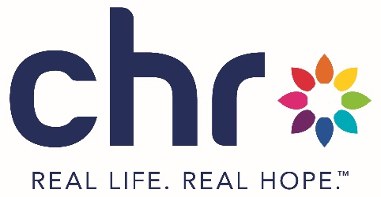
Course Cancellation and Refund Policy
CHR is committed to providing a quality educational experience to our participants. To ensure transparency and fairness, we have established the following cancellation and refund policy for our courses:
- Cancellation By Participant
  - Refund eligibility:
    - Participants may be eligible for a full or partial refund based on the timing of their cancellation.
    - Cancellation requests must be submitted in writing (via email) to CHR’s Mental Health Training Program at mhfa@chrhealth.org
  - Timely cancellation:
    - Participants who cancel 3 business days or more prior to the start of class will be issued a full refund.
      - For courses that require pre-work, cancellations made after the pre-work deadline will not be eligible for a refund.
    - Participants who cancel 2 business days or less prior to the start of class will not be eligible for a refund.
  - No-show policy:
    - Participants who do not attend the course, without prior notification meeting the timely cancellation guidelines (3 business days prior to the start of the course), will not be eligible for a refund.
- Cancellation by CHR
  - In the unlikely event that CHR must cancel a course, participants will be notified as soon as possible and given the option to transfer their registration to another available class or receive a full refund.
  - Courses that fall below the minimum participant requirement will be cancelled. Participants will be notified no less than 48 hours prior to the start of the course and given the option to transfer their registration to another available class or receive a full refund.
  - Courses that require pre-work must be cancelled if the number of participants eligible to attend the course does not meet the minimum participant requirement. Participants will be notified no less than 48 hours prior to the start of the course.
    - Participants who completed the pre-work requirement, or cancelled within the timely cancellation guidelines, will be given the option to transfer their registration to another available class or receive a full refund.
    - Participants who did not complete the pre-work requirements, or have not cancelled within the timely cancellation requirements, thus leading to the course cancellation, will not be eligible for a refund.
- How to request a refund
  - Participants must submit a refund request in writing to mhfa@chrhealth.org including their full name, contact information, course date, and reason for refund request.
  - Refunds will be processed within 30 days of CHR validating refund request.
- Exceptions: Exceptions to this policy may be considered on a case-by-case basis, taking into account extenuating circumstances.
This policy is subject to change without notice. Please check our website or contact us for the most-up-to-date information.

